Stop scrolling! - Season 1 Episode 1



Niklas Göke has one of the best hooks you’ll see on medium, writing, and the fishing world (his hooks are that good they’ll catch a fish).
(I intend to do more of these breakdowns — so if you like it, do well to clap at the end)
Scrolling through his profile and almost every headline reeled me in. That’s brilliant copywriting!
But,

Let’s take a look at this one in particular:
Someone Will Save You Today”
My first reaction was:
“wait! ?”
“Why should anyone care to save me?”

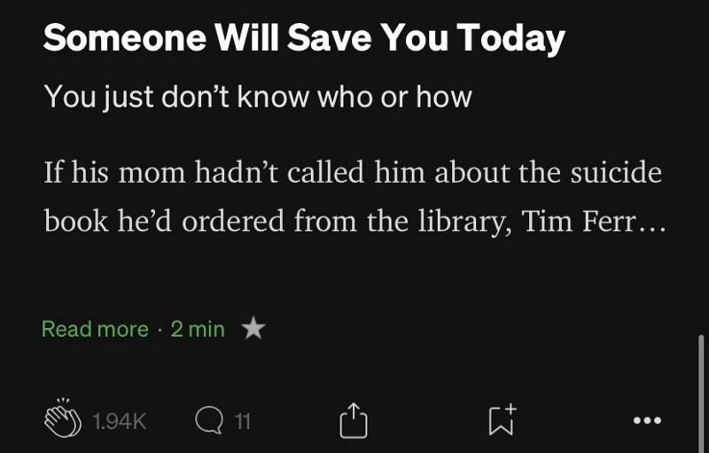
“Is someone about to give me a job that’ll change my life?”
“Financial saving? Yes, I want that”
“When am I getting saved?”
All these ran through my bald head.

He goes on to say:

And it gets me angry why I can’t know who this destiny helper is.

It’s already sad I don’t know when I’ll get saved — but at least I deserve to know this savior. Is it Jesus? Well, I got him already!

But Niklas sounds like it’s someone else. And he knows this person. Even worse, he’s not going to tell me except I chain him to a chair and put a knife across his hands threatening to cut them off. He wouldn’t want to risk not being able to write such tasty headlines ever again, Would he?
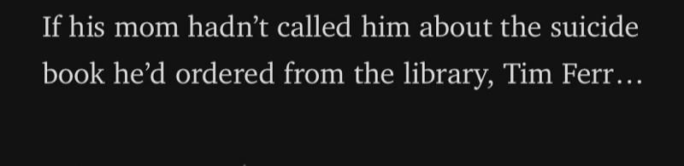
Now, it takes a twist and it’s clearly not about me anymore! *phewwww*
First of all, shout out to this Savior-mom, If it were my mom, she’d have beaten the suicide-ness out of me with strokes of:
“Why should you be depressed?”
“It’s of the devil”
“if you’re truly a Christian you should never experience such”.
Oh yes, I come from an overly religious home — the type that if you dare miss a service you’ll be tagged the right-hand man of the devil and probably earn some strokes and not a “call” like this Savior-mom.
If you read that line in the screenshot above you’ll be curious which “Tim” this is. My first guess was Tim Ferriss (“The Curator of experts?”). And I was right! But someone who has never heard of him would probably have thought of a “Tim” they once knew in high school.
Either way, it gets you curious to find out who this “Tim” is, what type of convo his mom had with him, if he was actually depressed or just carrying out research, if he took his life, etc.
But that’s what a great hook does. Right?
Stops your scroll, makes you grab a chair with your favorite coffee in hand, opens the curtain for you, and turns on the spotlight for the show to begin.
Over 1,000 people and 11 (possibly Savior-moms) are proof of the success of Niklas Göke’s show:


If you loved this read — please give it a 👏🏾

